Community Outreach Report
MENSTRUAL HEALTH AWARENESS OUTREACH

Date & Location
22nd May 2025
Kuchinguro Community Secondary School [Senior & Junior Secondary]

Host Committee & Supporting Offices/Partners
VP Internal Committee, NUMSA, Girl Child Advocacy- NiMSA, Maden Healthcare Foundation
The outreach was organized under the Office of the Vice President (Internal Affairs), supported by dedicated committee members and volunteers:

Team Lead/ VPI:
Tamunosaki Alexander Korubo

VPI Committee Members:
- Obinugwu Chinaza Anthonia
- Igwilo Mmesoma Claire
- Khadija Lawal Mohammed
- Salamatu Mohammed Usman

Public Relations Officers
- Yusraa Ashraf

Event Coordinators
- Tamunosaki Alexander Korubo
- Igwilo Mmesoma Claire

Social Media / Content Creation
- Yusraa Ashraf

Graphics Designers
- Khadija Lawal Mohammed
- Tamunosaki Alexander Korubo

Attendance / People Served
- 31 NUMSA volunteers
- 1 Maden Healthcare Foundation volunteer
- 300 students counselled

Step-by-Step Description
Planning Phase
- Date for the outreach was fixed by the committee.
- Flyers were designed and circulated for awareness.
- Donation requests were sent out and contributions received. Preparation & Setup
- Menstrual Pads were provided by NUMSA and Maden Healthcare Foundation.
- Event banner and pamphlets were produced for visibility and branding.
- Transportation was arranged for volunteers and materials.

Activities
- Administrative staff of Kuchinguro Secondary School were briefed and students were assembled.
- Basic Menstrual Health Education: Definition & Importance, Maintaining Proper Menstrual Hygiene, Debunking Myths about Menstrual Health and Gender Stereotypes.
- Demonstrations on how to properly use and dispose menstrual pads.
- Counselling for students with further questions.
- Referral advice was given where necessary.

Wrap-Up
- Pads were distributed.
- Team debrief held to summarize outcomes and areas for improvement.

Impact & Lessons Learned
- Empowered students with crucial knowledge about menstrual health.
- Misconceptions on menstrual health were corrected.
- Strong reminder of the value of community-centered health interventions.
- Reinforced the importance of adequate menstrual health practices.

Next Steps / Follow-up Plans
- Strengthening partnerships for larger-scale community health missions.
- Increased focus on menstrual health education and girl child empowerment.

MEDIA:

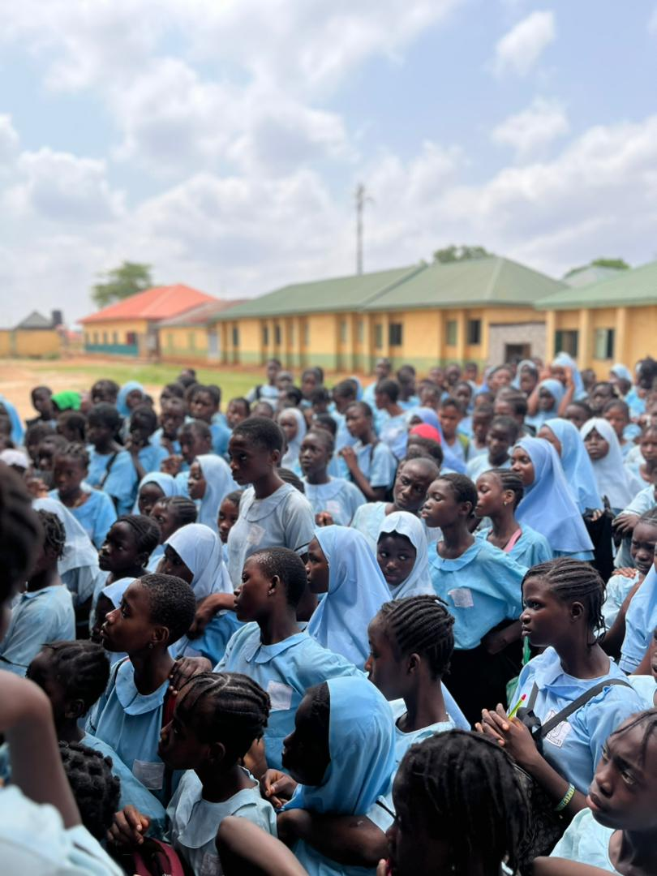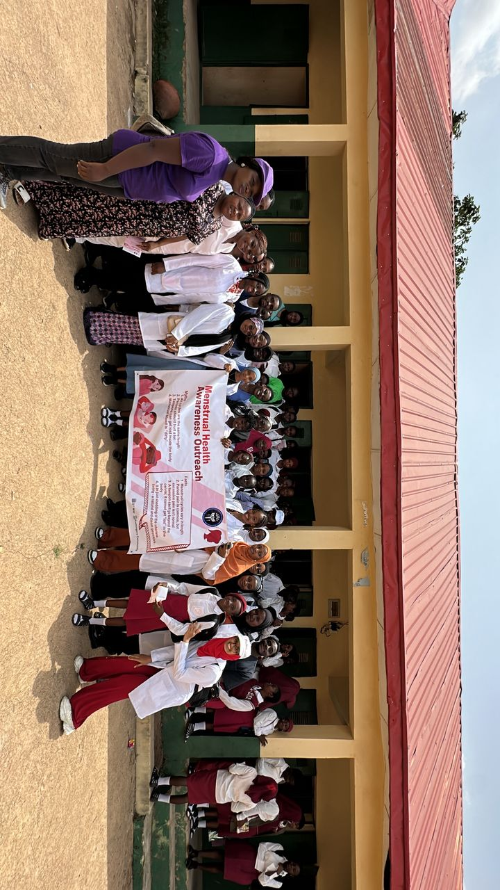

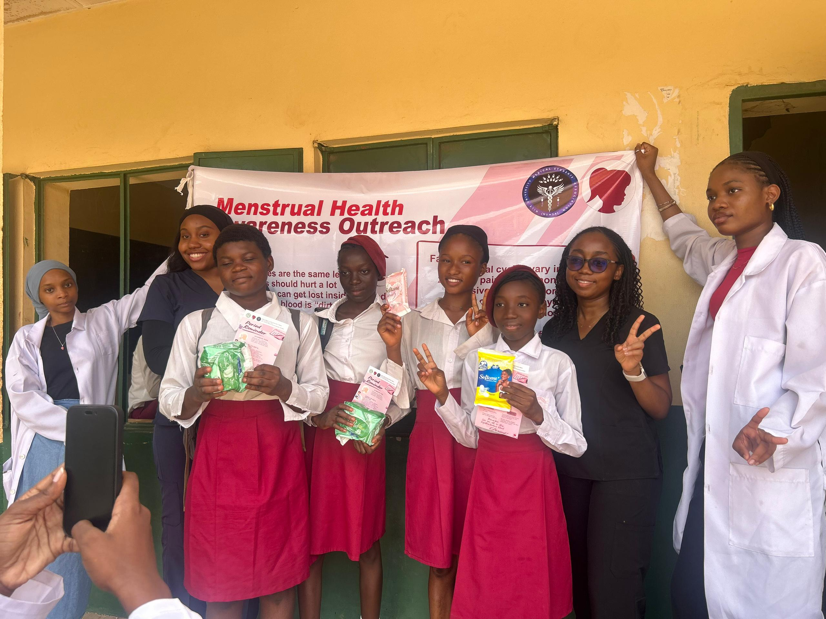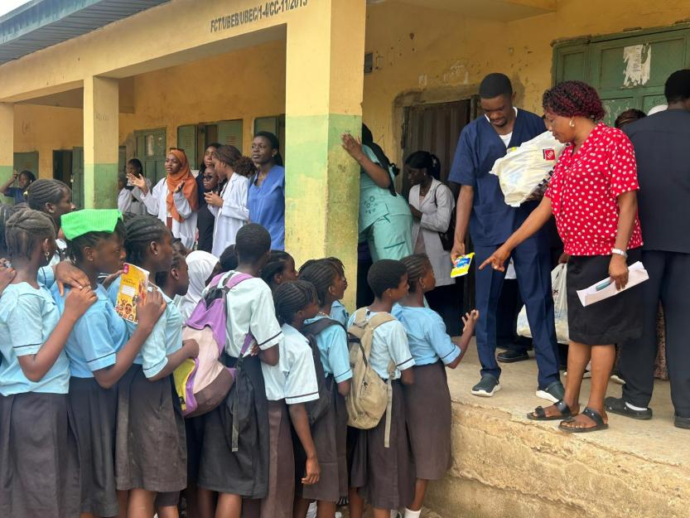

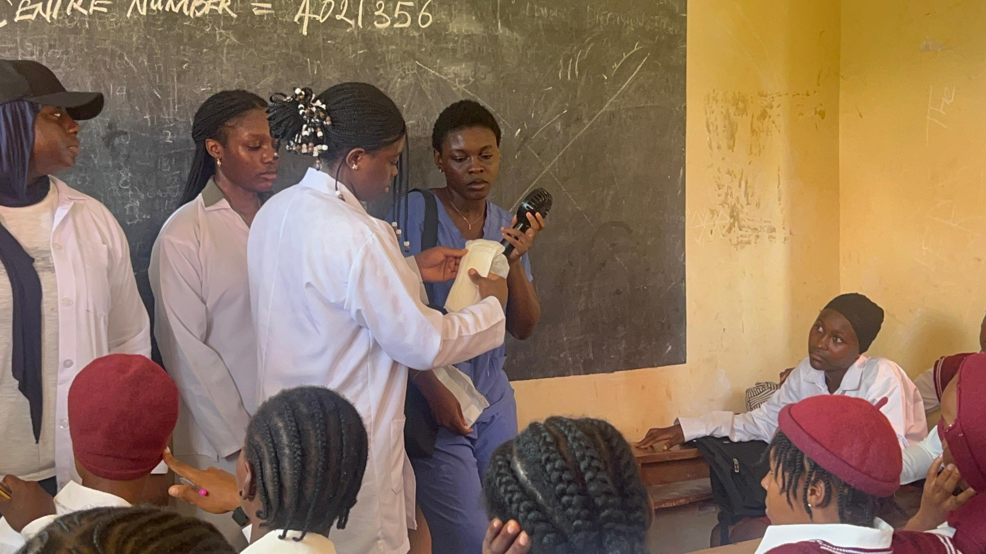

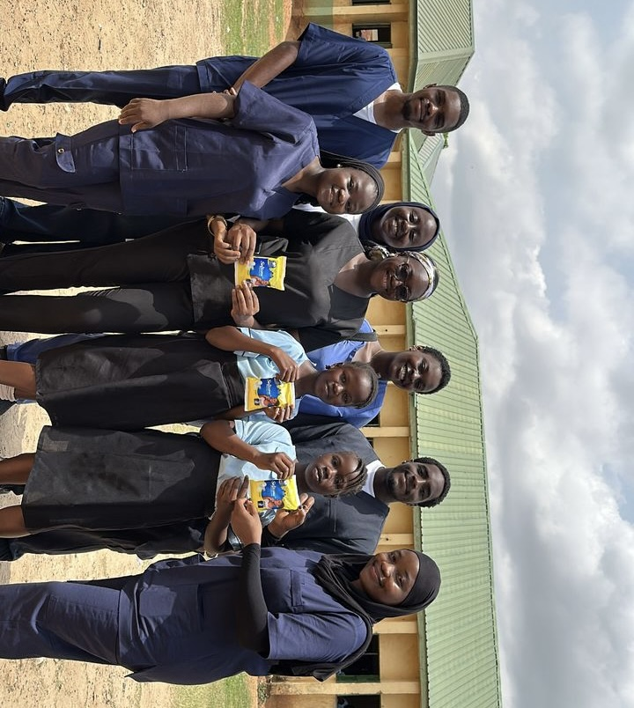

Video Link
https://www.instagram.com/p/DKNHIXUiLKr/?img_index=3&igsh=MTZtMmhjdXhobXpoMg==
https://www.instagram.com/p/DKGxmqQsAwW/?igsh=MXc4bTJzdnl5a2Ewaw==
Description: Short highlight reel showcasing activities, volunteer engagement, and interactions with students.

Media Consent
Media consent has been obtained for identifiable faces.

Credits
- Write-up Author: Emmanuella Eshiet
- Social Media / Content Creation Officer and Photographers: Yusraa Ashraf
- Partnering Organizations: Girl Child Advocacy- NiMSA, Maden Healthcare Foundation

